- What is DOM
DOM stands for Document Object Model. When a browser loads a web page, the browser creates a Document Object Model of that page
- In other words DOM contains the HTML elements as objects, their properties, methods and events and it is a standard for accessing, modifying, adding or deleting HTML elements.
- Interpolation example
<button disabled='{{isDisabled}}'>Click Me</button>
Property binding example
<button [disabled]='isDisabled'>Click Me</button>
- HTML attributes and the DOM properties are different things.
- Angular binding works with properties and events, and not attributes.
- The role of attributes is to initialize element properties and their job is done.

Angular:

What is AppModule
AppModule is the root module which bootstraps and launches the angular application. You can name it anything you want, but by convention it is named AppModule.
It imports 2 system modules - BrowserModule and NgModule
- BrowserModule - Every application that runs in a browser needs this module. In a later video in this course we will discuss NgIf and NgFor directives which are also provided by this module.
- NgModule - @component decorator adds metadata to an angular component class, similarly @NgModule decorator adds metadata to the angular module class.
In Part 4 of this tutorial, we discussed that if a class is decorated @component decorator then that class becomes an angular component. Similarly if a a class is decorated with @NgModule decorator then that class becomes an angular module.
Properties of the @NgModule decorator
- imports - Imports the BrowserModule required for an angular application to run in a web browser
- declarations - Contains the components registered with this module. In our case we have two - AppComponent and EmployeeComponent
- bootstrap - Contains the root component that Angular creates and inserts into the index.html host web page
Interpolation is all about data binding.

Both Interpolation and Property binding flows a value in one direction, i.e from a component's data property into a target element property.
Interpolation is a special syntax that Angular converts into a property binding.
Interpolation is just a convenient alternative to property binding.
In some cases like when we need to concatenate strings we have to use interpolation instead of property binding as shown in the example below.
<img src='http://www.pragimtech.com/{{imagePath}}' />
When setting an element property to a non-string data value, you must use property binding. In the following example, we are disabling a button by binding to the boolean property isDisabled.
<button [disabled]='isDisabled'>Click me</button>
If we use interpolation instead of property binding, the button is always disabled irrespective of isDisabled class property value
<button disabled='{{isDisabled}}'>Click me</button>
Some important points to keep in mind when using Property binding
Remember to enclose the property name with a pair of square brackets. If you omit the brackets, Angular treats the string as a constant and initializes the target property with that string.
<span [innerHTML]='pageHeader'></span>

What is the difference between HTML element attribute and DOM property
- Attributes are defined by HTML, where as properties are defined by the DOM.
- Attributes initialize DOM properties. Once the initialization complete, the attributes job is done.
- Property values can change, where as attribute values can't.
In the example below, we have set the value attribute of the input element to Tom.
<input id='inputId' type='text' value='Tom'>
At this point, run the web page and in the textbox you will see 'Tom' as the value.
Launch the browser developer tools.
On the 'Console' tab, use the getattribute() method and value property of the input element to get the attribute and property values. Notice at the moment both have the value 'Tom'
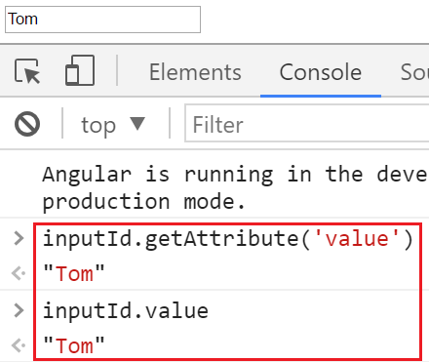

Change the value in the textbox to Mary.
Notice now, when we query for the attribute and property values, the attribute value is still Tom but the property value is Mary. So this proves the point - Property values change, where as attribute values don't.
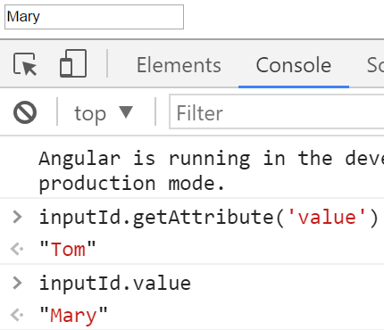
So it is important to keep in mind that,
Here are the steps to import FormsModule into our AppModule
1. Open app.module.ts file
2. Include the following import statement in it
import { FormsModule } from '@angular/forms';
3. Also, include FormsModule in the 'imports' array of @NgModule
imports: [BrowserModule, FormsModule]
With these changes, reload the web page and it will work as expected.
So here is the syntax for using two-way data binding in Angular
<input [(ngModel)]='name'>
A component has a lifecycle managed by Angular. Angular
- Creates the component
- Renders the component
- Creates and renders the component children
- Checks when the component data-bound properties change, and
- Destroys the component before removing it from the DOM
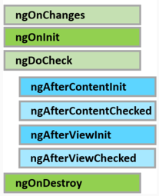

ngOnChanges | Executes, every time the value of an input property changes. The hook method receives a SimpleChanges object containing current and previous property values. This is called before ngOnInit
ngOnInit | Executes after the constructor and after ngOnChange hook for the first time. It is most commonly used for component initialisation and retrieving data from a database
ngOnDestroy | Executes just before angular destroys the component and generally used for performing cleanup

Why do we need a service in Angular
A service in Angular is generally used when you need to reuse data or logic across multiple components. Anytime you see logic or data-access duplicated across multiple components, think about refactoring that piece of logic or data-access code into a service. Using a service ensures we are not violating one of the Software principles - DRY ((Don't repeat yourself). The logic or data access is implemented once in a service, and the service can be used across all the components in our application.
Without the service you would have to repeat your code in each component. Imagine the overhead in terms of time and effort required to develop, debug, test and maintain the duplicated code across multiple places instead of having that duplicated code at one central place like a service and reusing that service where required.

- Template Driven Forms
- Model Driven Forms (Commonly called Reactive Forms)
Both these approaches have their own pros and cons. For example, Template Driven forms are generally used to create simple forms. On the other hand, Reactive forms are used to create complex forms. For example, if you want to add form controls dynamically or perform cross-field validation we use the Reactive forms approach.

he ngForm directive supplements the form element with additional features. It holds all the form controls that we create with ngModel directive and name attribute, and monitors their properties like value, dirty, touched, valid etc.

The ngSubmit directive submits the form when we hit the enter key or when we click the Submit button.
The ngForm directive is provided by Angular FormsModule. So for us to be able to use it, we will have to import the FormsModule in our AppModule file (app.module.ts). So please make sure to include the following import statement. Also include "FormsModule" in the imports array of @NgModule decorator.
import { FormsModule } from '@angular/forms';

/////////////////////////////////////////////////////////////////////////////////////////////////////////////////////////////////////////////////////////

Query String Parameters is somewhat similar to creating and reading required and optional route parameters.
Query parameters are usually used when you want the parameters on the route to be optional and when you want to retain those parameters across multiple routes.

Just like optional route parameters, query parameters are not part of the route configuration and therefore they are not used in route pattern matching
Passing query string parameters in code : We use the second argument of the Router service navigate() method to pass query string parameters.
- Create an object with queryParams as the key.
- The value is an object with key/value pairs.
- The key is the name of the query parameter and the value is the value for the query parameter.
this._router.navigate(['employees', employeeId], {
queryParams: { 'searchTerm': this.searchTerm, 'testParam': 'testValue' }
});

The query string parameters start with a question mark and are separated by & as you can see below.
http://localhost:4200/employees/3?searchTerm=John&testParam=testValue

<a [routerLink]="['/employees']"
[queryParams]="{ 'searchTerm': 'john', 'testParam': 'testValue'}">
List
</a>
Preserve or Merge Query String Parameters : By default, the query string parameters are not preserved or merged when navigating to a different route. To preserve or merge Query Params set queryParamsHandling to either preserve or merge respectively.
Preserve query string parameters in code
this._router.navigate(['/employees', this._id], {
queryParamsHandling: 'preserve'
});
Please note : queryParamsHandling is available in Angular 4 and later versions. If you are using Angular 2, you would not have queryParamsHandling. You will have to use preserveQueryParams and set it to true. preserveQueryParams is deprecated since Angular

To read query parameters we use ActivatedRoute service. We use this same service to read required and optional route parameters.
Inject the ActivatedRoute service using the component class constructor
constructor(private _route: ActivatedRoute) { }
Depending on your project requirements, you can then use either the snapshot approach or the observable approach.

In Angular there are 3 types of parameters.
- Required parameters
- Optional parameters
- Query parameters
When working with any of these parameters, the following properties and methods are very useful.
Member | Description
has(name) | Returns true if the parameter is present and false if not. Very useful to check for the existence of optional route and query parameters
get(name) | Returns the parameter value as a string if present, or null if not present in the map. Returns the first element if the parameter value is an array of values
getAll(name) | Returns a string array of the parameter value if found, or an empty array if the parameter is not present in the map. Use getAll when a single parameter could have multiple values
keys | Returns a string array of all the parameters in the map
Please note : For required and optional route parameters, we use the paramMap property of the ActivatedRoute object and for Query Parameters, we use queryParamMap property.
Use the snapshot approach if the query params does not change during the lifetime of this component.

